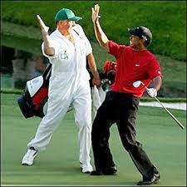
Caddy Training One Week Program Schedule

Day 1 PGCC classroom
8:00 am Greeting – Introduction – 10 Rules for Caddying
8:50 am Break – 10 minutes
9:00 am The Basic Job of Caddying & A Caddy’s Tools
9:50 am Break
10:00 am Getting Started & On the Tee
10:50 am Break
11:00 am Review & In class Practical “Greeting your group on the tee”
11:50 am Break
Noon – 1:00 Lunch
1:00 pm Through the Fairway & Around the Putting Green

1:50 pm Break

2:00 pm Bunkers, Hazards, Out of Bounds

2:50 pm Break

3:00 pm Teamwork, Health and Hints

4:00 Finished for the day

Day 2 PGCC classroom
8:00 am Review of topics from yesterday
8:50 am Break
9:00 am Golf Terms and Definitions
9:50 am Break
10:00 am The USGA Rules of Golf as they pertain to caddies

11:00 am Review of morning topics Question and Answer Period

12:00 – 1:00 pm Lunch

1:00 – 4:00 pm Practical Application at the golf course
- Issue caddy tools
- Issue bag & clubs
- Issue caddy bibs
- On the tee – greeting – instructor demonstrate – students perform task
- Around the Green – instructors demonstrate – students perform task
- Raking Bunkers – instructors demonstrate – students perform task
- Turn in caddy tools, bags, clubs, bibs

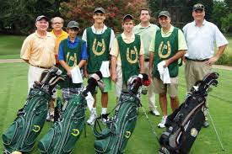

Day 3 Golf Course – The Legends

8:00 am Caddy Hand signals – instructors demonstrate – students perform task

9:00 am Through the Fairway – instructors demonstrate – students perform task

10:00 am Hazards, Out of Bounds – discussion – instructors demonstrate

12:00 Lunch

1:00 – 3:00 Issue caddy tool; Divide into groups – discuss teamwork – instructors demonstrate – students perform

3:00-4:00 Turn in caddy tools

Day 4 Golf Course – Caddy for each other

9:00 am Issue caddy tools, divide group into 2 groups. Group A & Group B.
10-12:00 Group A will caddy for Group B ….will play 9 holes

12:00 Lunch

1-3:00 pm Group B will caddy for Group A….will play 9 holes

Day 5 Golf Course – Review and

11am Review of Practical Application – Issue caddy tools: students will caddy for PGCC students in tournament setting in the afternoon followed by “Caddy Graduation & Banquet”

